SOLID PRINCIPLES
Design patterns to make software designs more understandable, flexible and maintainable
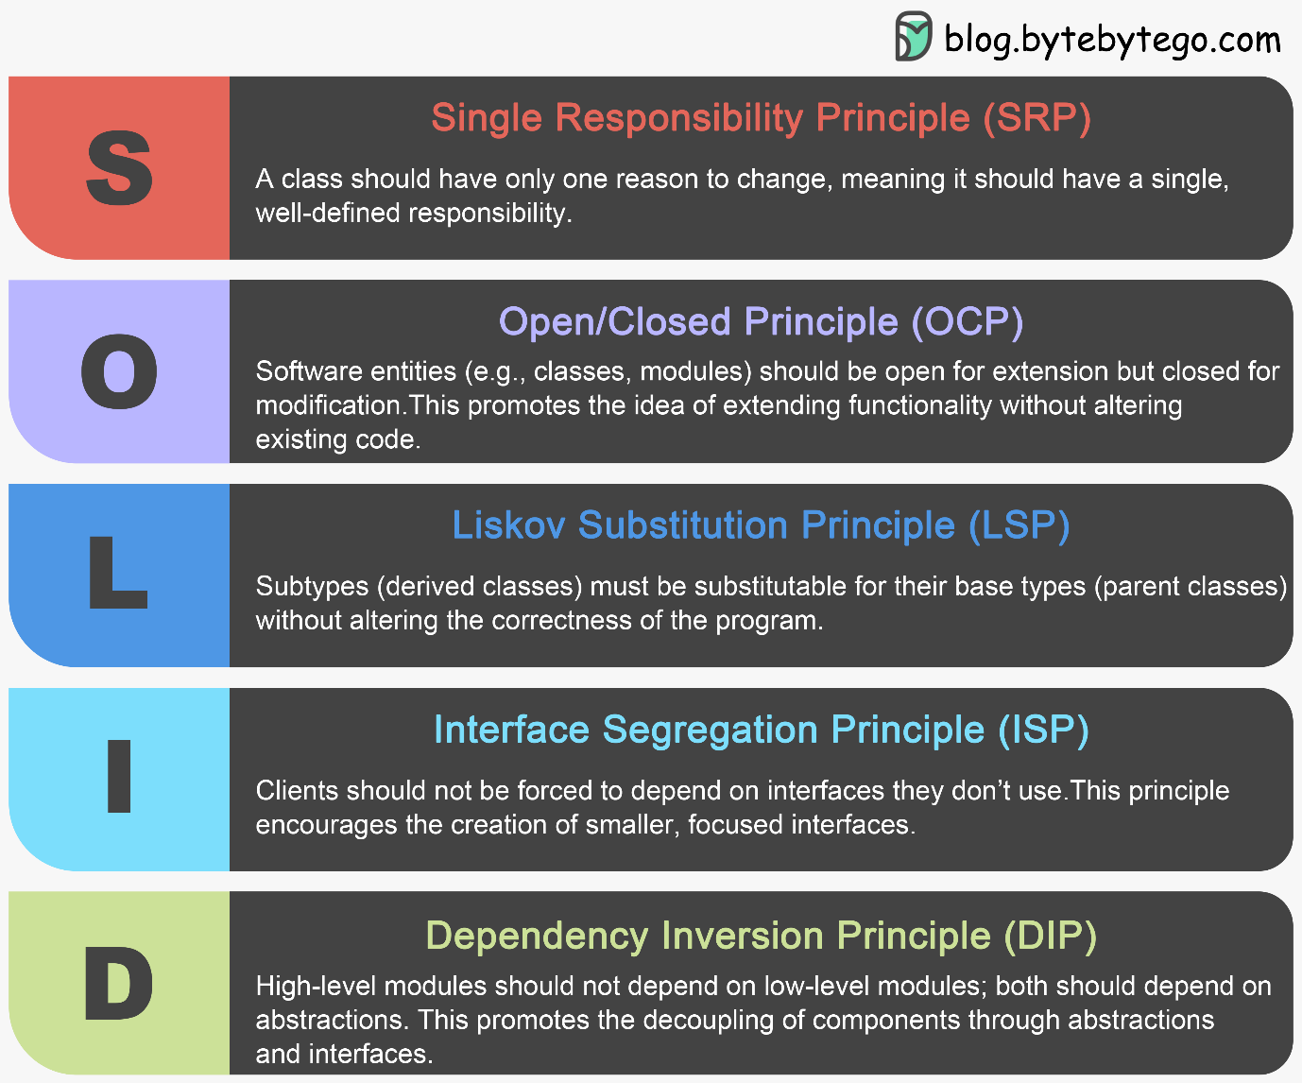

1.Single Responsibility Principle(SRP)
single responsibility principle states that every class must have a single, focused responsibility, a single reason to change.
public class Employee{
public String getDesignation(int employeeID){ // }
public void updateSalary(int employeeID){ // }
public void sendMail(){ // }
}

public class Employee{
public String getDesignation(int employeeID){ // }
public void updateSalary(int employeeID){ // }
}

public class NotificationService {
public void sendMail() { // }
}

2.Open/Closed Principle (OCP)
Component should be open for extension and closed for modification
public class AreaCalculator(){
public double area(Shape shape){
double areaOfShape;
if(shape instanceof Square){
// calculate the area of Square
} else if(shape instanceof Circle){
// calculate the area of Circle
}
return areaOfShape;
}

interface IAreaCalculator(){
double area();
}
class Square implements IAreaCalculator{
@Override
public void area(){
System.out.println("Calculating area for Square"); }
}
class Circle implements IAreaCalculator{
@Override
public void area(){
System.out.println("Calculating area for Circle"); }
}

3.Liskov Substitution Principle (LSP)
A superclass object could be replaced with a subclass object without affecting the correctness of program.
abstract class Bird{
abstract void fly();
}
class Eagle extends Bird {
@Override
public void fly() { // some implementation }
}
class Ostrich extends Bird {
@Override
public void fly() { // dummy implementation }
}

abstract class FlyingBird{
abstract void fly();
}
abstract class NonFlyingBird{
abstract void doSomething();
}
class Eagle extends FlyingBird {
@Override
public void fly() { // some implementation }
}
class Ostrich extends NonFlyingBird {
@Override
public void doSomething() { // some implementation }
}
4.Interface Segregation Principle (ISP)
According to the interface segregation principle, you should build small, focused interfaces that do not force the client to implement behaviour they do not need.
interface IShapeAreaCalculator(){
double calculateArea();
double calculateVolume();
}

class Square implements IShapeAreaCalculator{
double calculateArea(){ // calculate the area }
double calculateVolume(){ // dummy implementation }
}

interface IAreaCalculator {
double calculateArea();
}

interface IVolumeCalculator {
double calculateVolume();
}

class Square implements IAreaCalculator {
@Override
public double calculateArea() { // calculate the area }
}

class Cube implements IAreaCalculator, IVolumeCalculator {
@Override
public double calculateArea() { // calculate the area }

@Override
public double calculateVolume() {// calculate the volume }
}

5.Dependency Inversion Principle (DIP)
High level modules should not depend on low level module or follow abstraction and ensure loose coupling
public interface Notification {
void notify();
}
public class EmailNotification implements Notification {
public void notify() {
System.out.println("Sending notification via email");
}
}
public class Employee {
private EmailNotification emailNotification;
public Employee(EmailNotification emailNotification) {
this.emailNotification = emailNotification;
}
public void notifyUser() {
emailNotification.notify();
}
}

public interface Notification{
public void notify();
}
public class Employee{
private Notification notification;
public Employee(Notification notification){
this.notification = notification;
}
public void notifyUser(){
notification.notify();
}}
public class EmailNotification implements Notification{
public void notify(){
//implement notification via email
}}
public static void main(String [] args){
Notification notification = new EmailNotification();
Employee employee = new Employee(notification);
employee.notifyUser();
}

